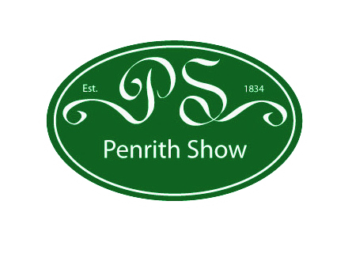

Dear Business Owner,
Please could we take a moment of your precious time as this could be a wonderful opportunity for your business...

Food and Farming Festival 2013
Are you looking for new ways to highlight your services, products and skills?

Would you enjoy being part of a successful event?

Would you join in so that your business benefits from the efforts being made?

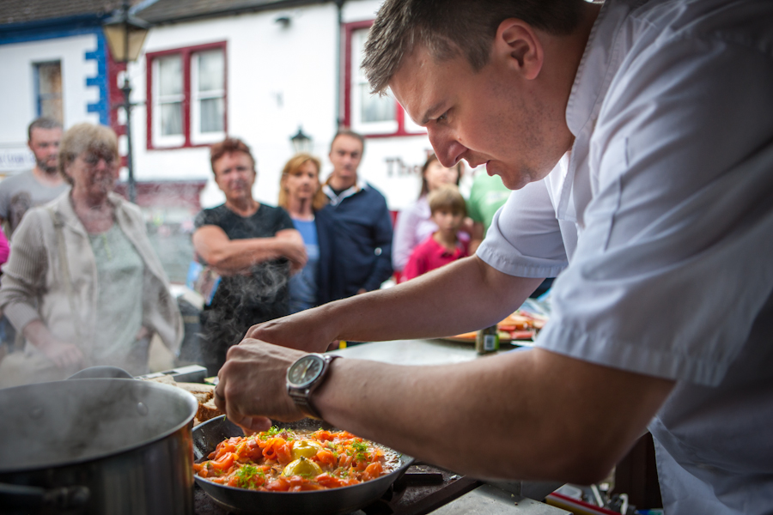
Eden’s Food and Farming Festival is a new week long festival that has been developed from the successful ‘Penrith on a Plate’ event in July 2012.

The Festival will begin in Penrith on the 20th of July with ‘Penrith on a Plate’ a day of food tastings, demonstrations, a local food market and celebration of food in our community. Footfall for this event is expected to exceed the previous figure of 3 – 5000.

The Festival will continue with a week long programme of events with offers in restaurants and food outlets, educational manufacturers / farm tours, ending with the annual agricultural event ‘Penrith Show’.

We would like to invite all local food businesses to be involved with this event and welcome any input you may wish to have. It doesn’t matter what kind of business you are part of, everyone can benefit by finding a way to contribute. For example, there will be stalls positioned throughout the town for businesses wishing to sell or offer samples of their produce or maybe you would like to get creative and attract attention in another way?!...

Samples and Tasters Traders can take a stand outside their premises or another area in town to give away samples of their best dishes.

Promotional Offers An event programme will be produced providing information about the Food and Farming Festival, Penrith on a Plate, offers throughout the week and Penrith Show. If you would like to offer a promotion, discount, trail, farm visit, class or event, please let us know and we will include you in the programme.

Entertainment Live music and fun activites are planned for the festival, if you would like to host some entertainment or know of anyone you would like to be involved, particularly with a food or farming theme, then please let us know.
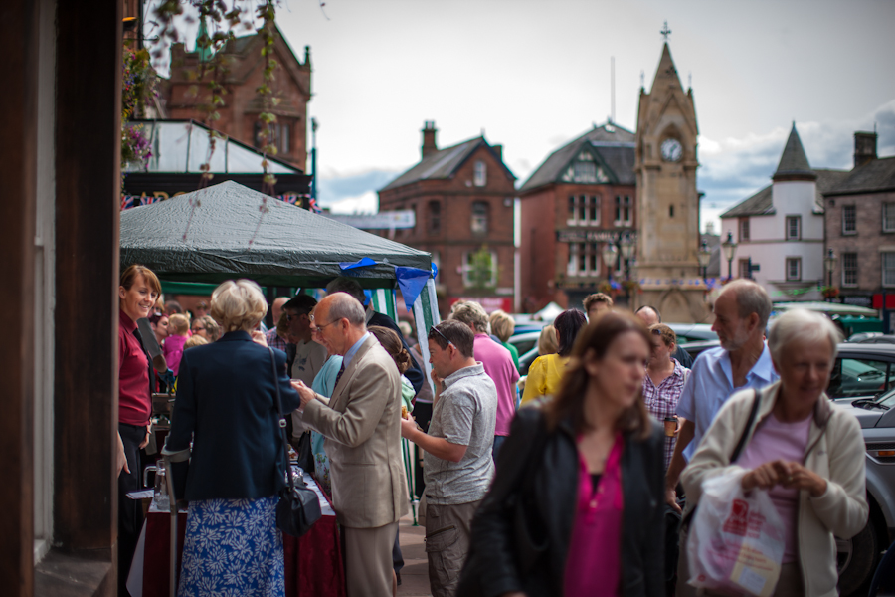
Competition Businesses are invited to put forward any ideas for competitions along the themes of food and farming. The option of organising and running your own competition is available too, giving businesses the opportunity to raise their profile by putting their name to a fun event. .

Sponsorship: We welcome any offers of sponsorship for the various elements of the food and farming festival such as for competitions, specific demonstrations, marquee / equipment hire, parking, services etc.

Other: If you aren’t food or farming related, can you find a link in some way either to the people involved in these elements or the services required for them? For instance, can you provide stylish clothes for off duty farmers or chefs, create activities for local children, support a local animal charity or just promote items to help eat or prepare great local food? There is always a way to get involved!
If you would like to take advantage of this event, please acknowledge interest by replying via the application form by 17th May.
This will ensure that your stand and details are incorporated in the brouchure that we are producing and associated publicity. After this date we would be happy to take a booking but unable to guarantee the publicity.
If you have any queries, please email penrithfoodandfarming@gmail.com. If you think someone else may be interested, please forward these details on. We look forward to hearing from you soon!
Kind regards,

Peter Ward
Other Committee Members:
Peter Ward - peter.j.ward@hotmail.co.uk (Penrith Partnership)
Richard Utting - richard.utting@profilefm.co.uk (Penrith Chamber of Trade)
Carol Grey - carol.grey@eden.gov.uk (Town Centre Officer, Eden District Council)
Yvonne Burrows - Yvonne.burrows@eden.gov.uk (Town Centre Officer, Eden District Council)
Dan Harding - danielhardings@hotmail.com (Business Owner & Town Centre Ambassador)
Melanie Hall - melhall@btinternet.com (Business Owner)
Annabel Candler - annabelcandler@gmail.com (Event Consultant)

