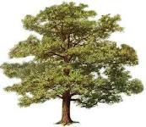
JOHN RICHARDSON & SON
Roper Street - Penrith - CA11 8HS
T: 01768 895000.
E: www.johnrichardsonandson-timber.co.uk
Celebrating 160 Years of Service

XMAS TREE INFORMATION
Xmas Tree with peeled shank, galvanised bracket + fixings + decorative lights £39.95 + VAT
Installation + removal + disposal £10.00 + VAT
Xmas Tree with peeled shank + installation + removal £29.95 + VAT
Any additional lights required please contact Kelvin Dixon @ Seagrave & Dixon

Deadline: Payment must be received before the 21st October

